***EJERCICIOS EDITOR DE TEXTOS***

**1** - En grupos de dos personas: realizar la siguiente traducción en un documento de texto de DRIVE.  
Los párrafos impares estan traducidos (y bien formados, no solo con traductor online) por una persona. La otra persona se encarga de los párrafos pares.

Añadir texto explicando qué es lo que se ha entendido traduciendo el documento.  
<https://www.fastcompany.com/3028575/a-practical-guide-to-becoming-a-whole-developer>

#### Comunication

“Language is our most distinctly human capability, and it underlines everything that we do,” Ali says. “Considering this, it’s surprising how neglected communication has been in the business world, until very recently. Communicative acumen can increase team harmony, diffuse conflicts, and salvage reputations.”

A big part of being a Whole Developer is communicating effectively. This goes beyond just getting along with people–it means being able to deliver persuasive, trenchant messaging that gets your point across and compels others to act on it.

Ali says that she’s often seen brilliant products come out of the hackathons she runs but then when the developer gets to the stage to present their product, they don’t have the communication skills to convey the product in all its glory.

“Salespeople, marketers, and spokespeople are masters at it, and developers would do well to learn what could be one of the most powerful tools in their soft-skill toolkit.”

When conveying your idea to an audience, frame it in a context they can understand. For example, if your audience isn’t technical, focusing on how much of an engineering marvel your product is won’t excite them. Talk to them about how they will benefit from it. See things through their eyes and communicate with them as if you were watching them explain something to themselves.

#### TEAM BUILDING

Despite the prevailing stereotype of the developer as an anti-social recluse, the fact is that developers don’t work in a vacuum. In any organization, there are teams involved, and developers will need to interact with team members. These can be other developers, or marketers, administrators, or executives. Either way, it’s important for developers to know how to manage and navigate team dynamics.

“Developers are known to be isolated workers,” Ali says. “Because of this misconception many developers haven’t had the ability to understand or take part in the full scope of work that’s being created. Moreover, when placed in a leadership role the developer turned manager might take misguided approaches to forming a team, managing a team, and ultimately this leads to a non-productive work environment.”

Ali says it’s important to address any issues your team raises quickly, fully, and, most importantly, consistently. This can be done by planning ahead and exploring how you’d react to situations before they arise. Your “pre-attention” to matters will help build cohesiveness between your team. Specifically, developers turned managers should be prepared to address some of the following common issues around their teams:

“Where will each team member be more effective? What if a team member doesn’t deliver? What if there’s conflict? Is there potential for misunderstanding when working with multicultural teams? When should a leader become a follower?”

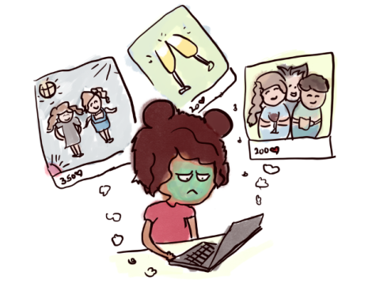2- Crear el siguiente documento, traducido, en WORD

How does confirmation bias work?  
1. How you seek information

Confirmation bias affects how you look at the world around you.

When you’re alone at home feeling lousy, you immediately jump onto Facebook or Instagram. You look at pictures of people traveling, partying, getting married and think everyone I know is living a great life. You say to yourself, “I am such a lonely loser.”

You sit at home and feel crappy — all because you chose to seek information that confirms your crummy feelings. You knew looking at those photos would make you feel worse but you sought them anyway.

#### 2. How you interpret the information in front of you

Confirmation bias also affects how you process what is otherwise neutral information — and it tends to favor your beliefs.

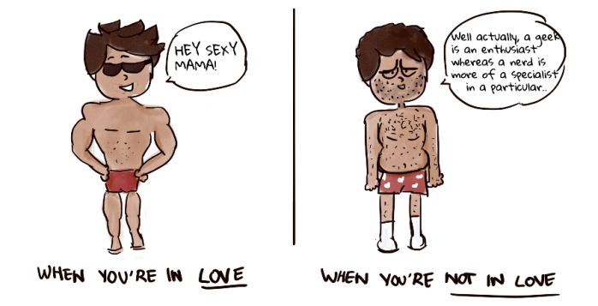When you are falling in love, all you see in your partner is a beautiful, perfect Adonis. You don’t notice a single flaw. When that relationship sours, all of a sudden, all you see are flaws — their coffee breath, their penchant for droning endlessly about a topic you don’t care about, the hairs they leave in the sink.

You are dating the exact same person, but you perceive the things they do differently based on how you feel.

So what can I do about it?

<https://medium.com/behavior-design/confirmation-bias-why-you-make-terrible-life-choices-43fc6d6dcbe1>

1. Approach life with curiosity not conviction

When you walk into every interaction trying to prove yourself right, you’re going to succumb to confirmation bias.

[Researchers](https://www.ncbi.nlm.nih.gov/pubmed/2130257) studied two groups of children in school. The first group avoided challenging problems because it came with a high risk of being wrong. The other actively sought them out for the learning opportunity, even though they might be wrong. The second group consistently outperformed the first.

Focus less on being right and more on experiencing life with curiosity and wonder. When you’re willing to be wrong, you open yourself up to new insights.

[](https://medium.com/@lakshmoo?source=footer_card)2. Seek and understand disagreement

Understanding various viewpoints can help you refine your perspective. According to researchers, you can actually change your deep seated beliefs. The trick? Surround yourself with a variety of opposing viewpoints. [Lakshmi Mani](https://medium.com/@lakshmoo)

3 - En grupos de 3 personas:

Una persona será el responsable del proyecto y las otras dos colaboran a traves de GITHUB.

El responsable crea un documento en formato MARKDOWN donde los tres colaboran. Cada miembro del grupo traduce y añade al documento UNO de los siguientes 10 apartados:

<https://www.computersciencezone.org/10-skills-necessary-coding/>

Al final se añade texto explicativo de lo que se ha entendido.